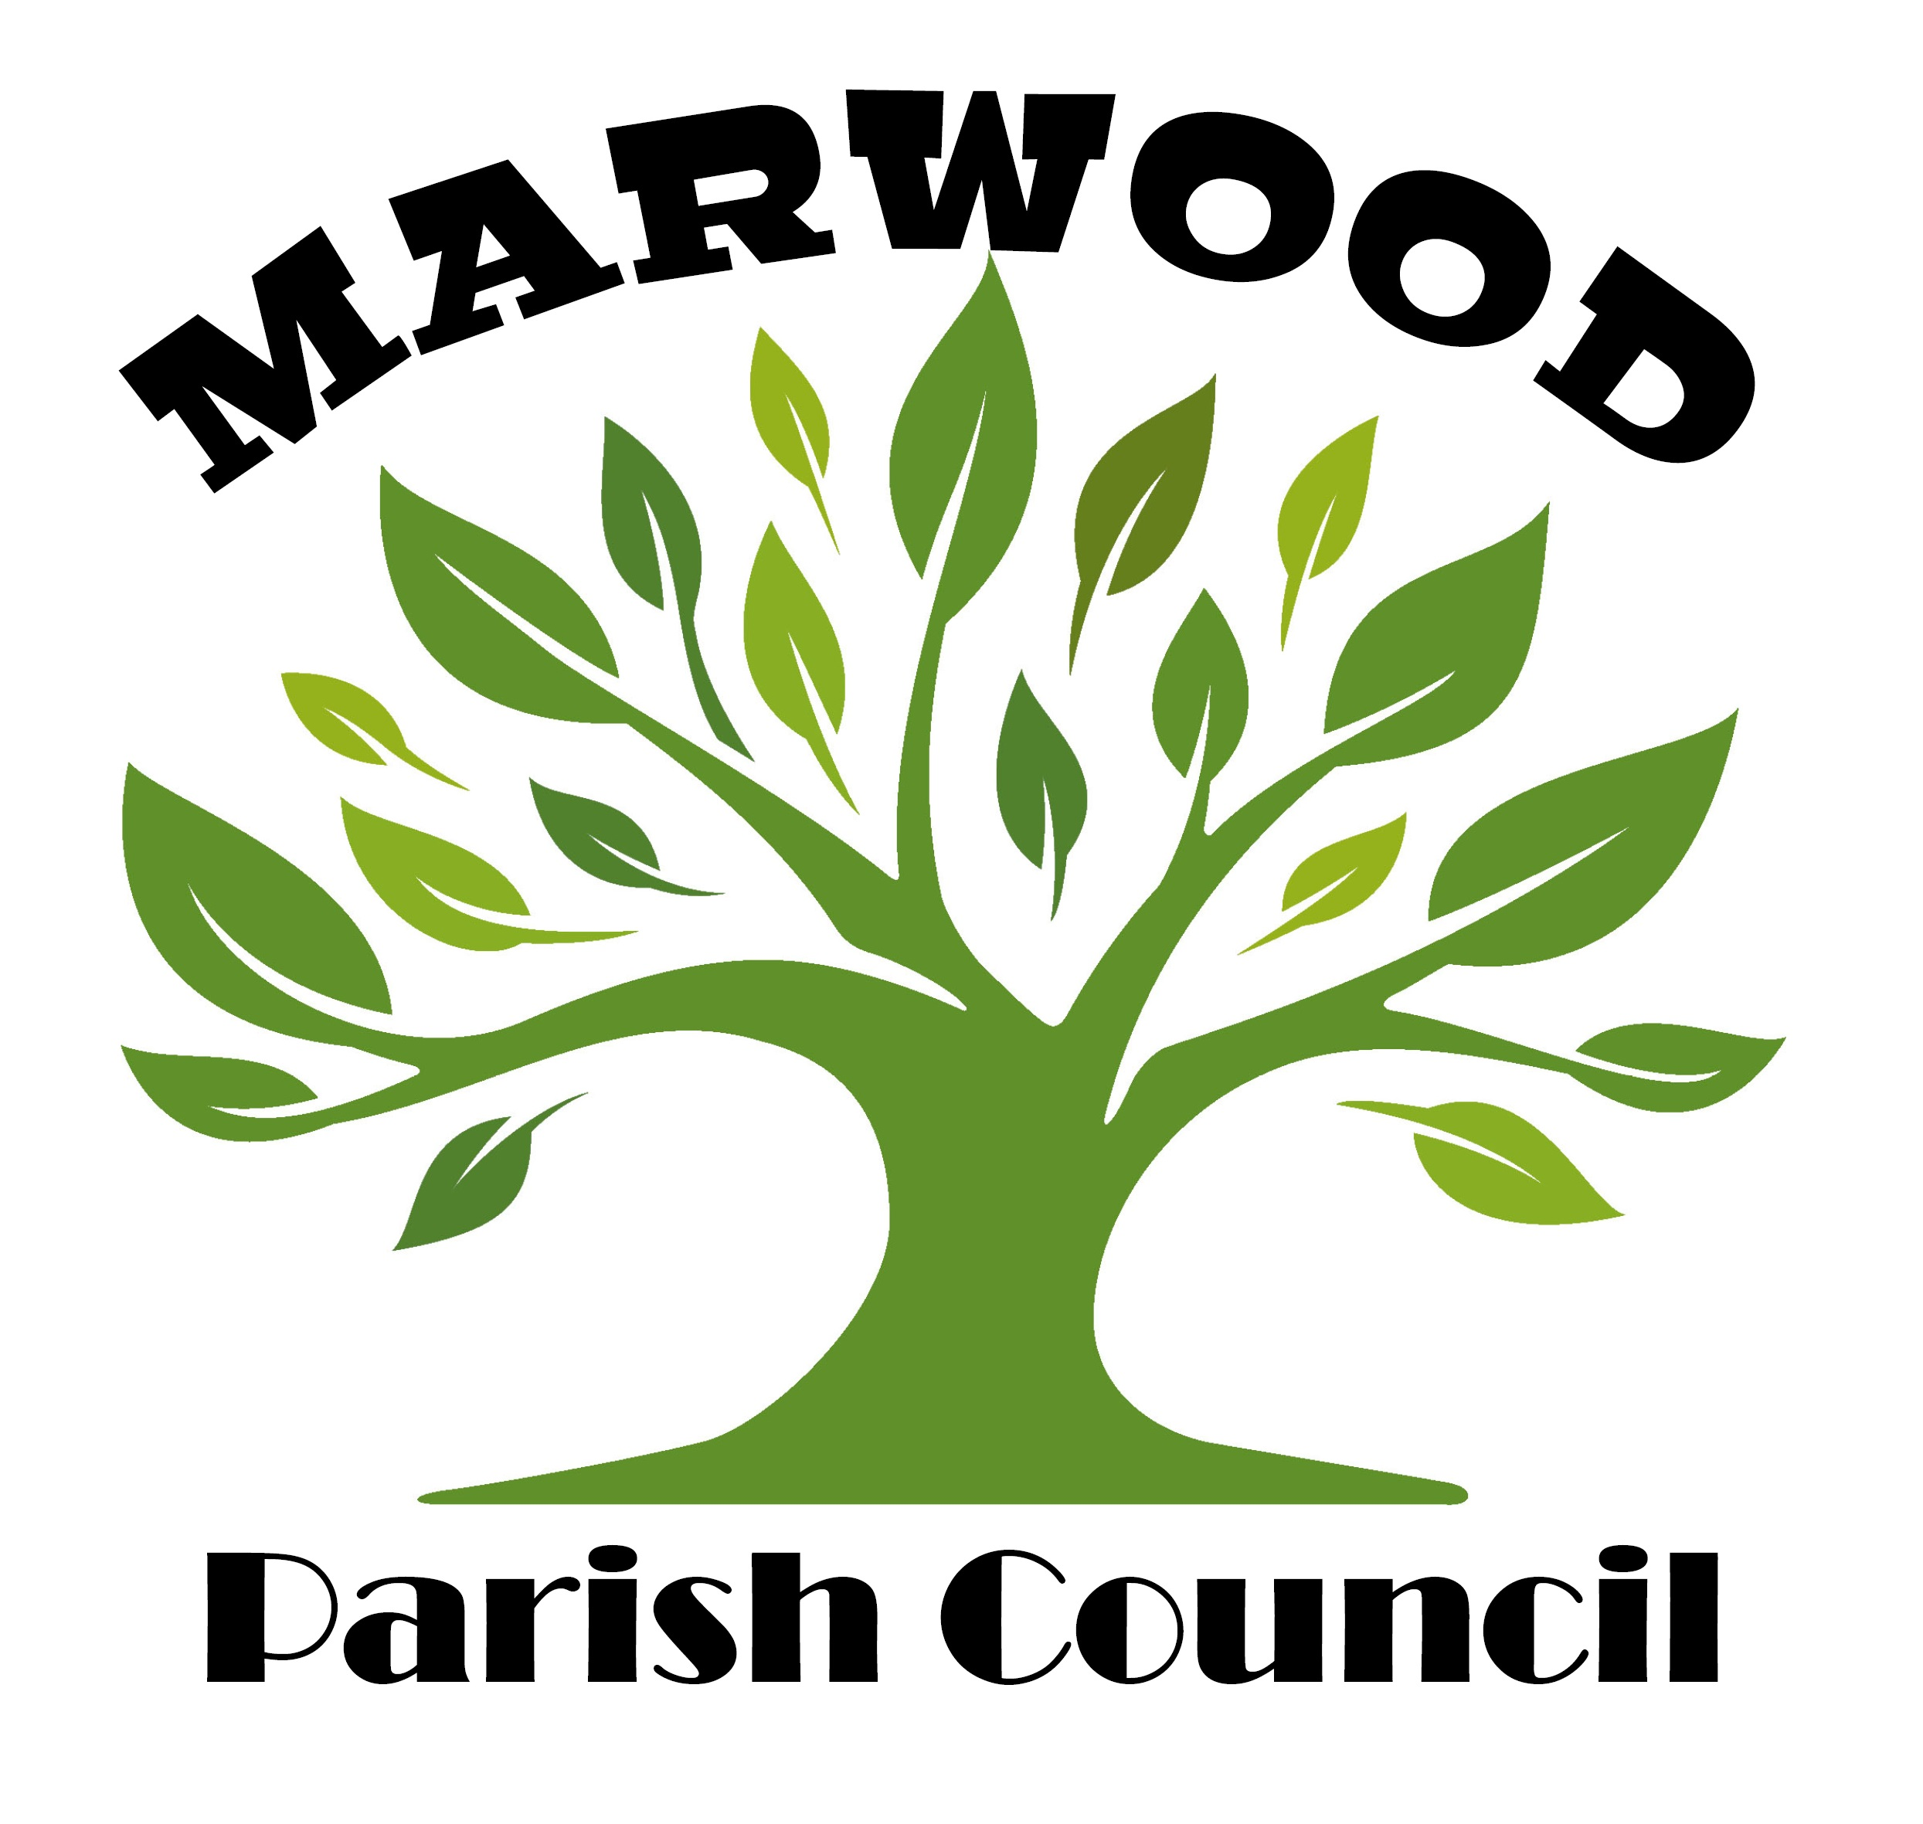

Parish Clerk
Chatwood Lodge
Stainton Village
Barnard Castle
DL12 8RD

BY: E: MAIL & LETTER

Planning Ref: DM/20/03070/OUT

Date: 23rd November 2020

Mr B Gavillet
Case Officer
Planning Development
(Strategic)
Room 4/123-128
Durham County Council
County Hall
Durham
DH1 5UL

Dear Mr Gavillet

DM/20/03070/OUT Residential development of up 100 units and associated parking, open space, landscaping and access/Land To The North of Darlington Road Barnard Castle DL12 8QG
On behalf of Marwood Parish Council, please find our objections to the proposed Banks Group outline Planning Application to build up to 100 new homes. East Side of Castle Vale on Darlington Road (A67) Barnard Castle. This site falls within the Marwood Parish Boundary.

Barnard Castle is a popular historic market town which attracts a high level of tourism all year round as well as a main transport route to the Teesdale North Pennines. Due to this, the road network infrastructure is constantly compromised with excessive road traffic especially along Darlington Road (A67) and the busy neighbouring areas of (A688) (Teesdale School, Lidl development under construction, the Hub) and Bede Road Access exit – town centre, as these three roads converge on the roundabout at the local service station where there is already frequent queuing at pivotal points throughout the day.

To be continued ….

01833 637392 marwoodparishcouncil@outlook.com
www.marwoodparishcouncil.co.uk

2.

The proposed site will be an approximate 30 minute walk into the town centre, therefore the vast majority of the new 100 homes will use their cars to access the town (including construction traffic during the build process) all along Darlington Road, which will be inconceivable given the level of congestion at the present moment.

The issue of safety is a high priority. Darlington Road is in a 30mph zone. However, this speed very rarely gets adhered to and is constantly under surveillance from both the police & local speed awareness group as this is a main foot traffic route for the local schools with very limited safe crossing points.
The local area has had four new housing estates plus small new build sites during recent years, the larger developments are Taylor Wimpey Castle Vale on Darlington Road next to the proposed new development, Taylor Wimpey Bowes Gardens, David Wilson Five Acres and Kier Living Castle Croft which have all contributed to the local and national housing requirement all be it with a negative and detrimental impact on the local landscape.

The local amenities and facilities such as schools, doctors & dental surgeries are already overwhelmed by the previous rapid growth of the town and another new housing estate would considerably add to these issues along with more pressure on already limited parking spaces in the town centre.

The proposed development is on arable land which is invaluable to the local wildlife and natural habitats that rely on this area which has already been considerably affected during the construction of the Castle Vale development. Surely it would now be feasible to leave this field as the sanctuary that has evolved overtime for wildlife.

There was a recent article in the Teesdale Mercury highlighting that the local sewers are stretched in the Barnard Castle area, with comments advising that these issues have stemmed from the previous new build housing which the current sewer network cannot cope with, therefore another development would surely make these issues worse.

When the County Durham Plan Pre Submission Draft was discussed, this site with regard to the land East of Castle Vale was not listed in the housing allocation for West Durham. (6/BC/21 Land to the East of Ashtree Vale ). “The SHLAA Assessment” reported that the development on this site would comprise an incursion into attractive open countryside (AHLV) beyond newly established settlement edge, not well related to existing settlement form and with great prominence and impact than development to the west. Likely to have significant landscape effects (significant adverse residual impact).

To be continued….

3.
We hope the above clearly highlights our objections to this proposed development. We feel it is important to protect our unique and picturesque market town from urban sprawl into open countryside.

Yours faithfully

Miriam Fenwick
Parish Clerk
For and on behalf of Marwood Parish Council

c.c S Timmiss Head of Development and Housing

